FLOWCHART | PERSON RESPONSIBLE | TIME FRAME
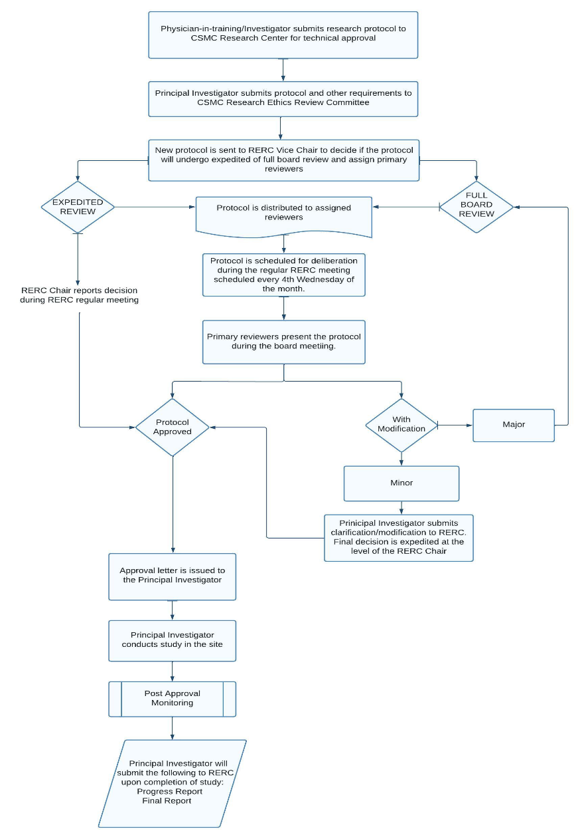 | Physician-in-training/ Investigator
 | RERC Vice Chair | 1 week from the date of receipt
 | RERC Secretariat Staff | 1 week from the date of receipt
 | Primary Reviewers | 1-2 weeks
 | RERC Secretariat Staff | 1 week
 | Principal Investigator | Approval to conduct study for 1 year

