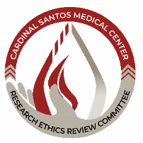


RESEARCH ETHICS REVIEW COMMITTEE

Version | 5
Supersedes | SOP Version 4
Authored by | CSMC RERC (Adopted from DOH SOP)
Effective Date
Approved by | PURA R. CAISIP, M.D., MPH  Chair, CSMC RERC
Approved by | ANTONIO S. SAY, M.D., MHPEd  Chief Medical Officer
Approved by | MR. RAUL C. PAGDANGANAN  President & Chief Executive Officer
Approval Date
STANDARD OPERATING PROCEDURES

